The goal is to understand how the serialization and de serialization concept from java is used in Rest Assured

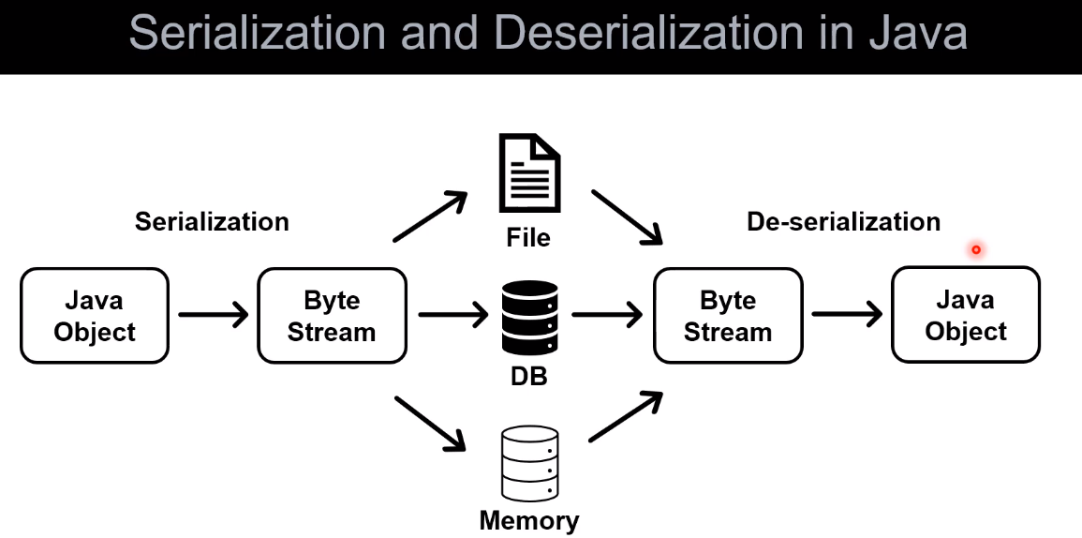

Java object is converted to byte stream and this process is called - **Serialization**. Then the byte stream can be stored in a file or a database or memory. Then the byte stream is fetched (извлеченный) and is converted back to the Java object, this process is called - **de serialization**.

Why are we doing this ?

Because the byte stream is platform independent, it can be used anywhere by any platform. If we do not use serialization / deserialization we will face the problem that if we have a Java object, then it is compatible with the Java programming language only. And if it is byte stream it can be used in any programming language.

The byte stream represents the data.